1.6 JDBC Sampler Script



This section will guide you:

* To use the JDBC Sampler Script

**Development Environment:**

* Apache JMeter 5.1.1 Version
* Open JDK Runtime Environment 11.0.2

This guide has six sub-sections, namely:

1.6.1 Setting up a database

1.6.2 Downloading database specific jar and placing it in lib

1.6.3 Setting up the JDBC Config Manager

1.6.4 Adding and configuring the JDBC Sampler

1.6.5 Writing the queries and viewing the result

1.6.6 Pushing the code to GitHub repositories

**Step 1.6.1:** Setting up a database (with database name, username, password, and port)

* Open your database.
* Create a database and then create a table.

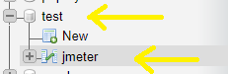

**Step 1.6.2:** Downloading database specific jar and placing it in lib

* mysql-connector-java jar file is already present in your practice lab.

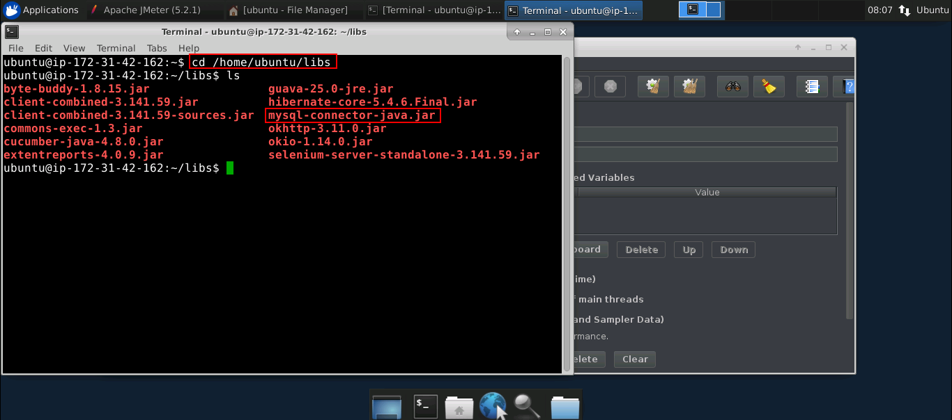

* Add that jar file in the JMeter bin folder.
* Now, restart your JMeter.

**Step 1.6.3:** Setting up theJDBC Config Manager

* Open JMeter.
* Right click on Test Plan.
* Click on Add -> Thread (Users) -> Thread Group.

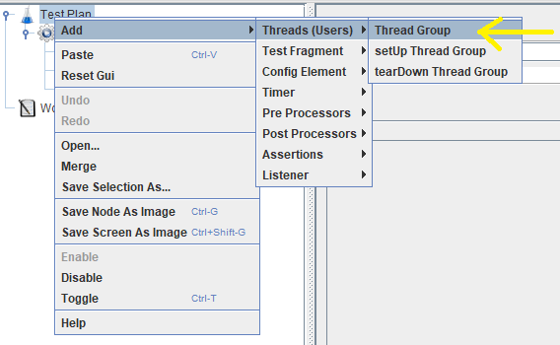

* Right click on the Thread Group.
* Click on Add -> Config Element -> JDBC Connection Configuration.

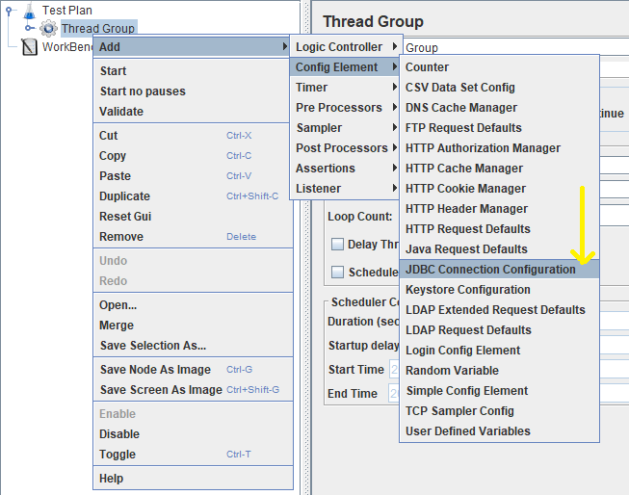

* Enter your database URL.
* Enter your JDBC Driver Class (based on your custom database).
* Enter your username and password.

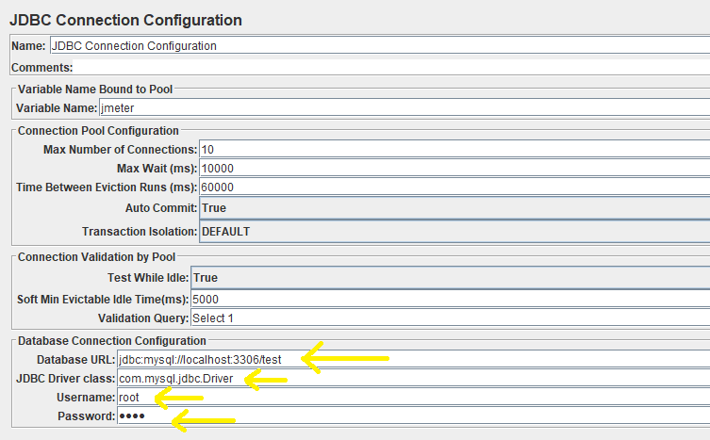

**Step 1.6.4:**  Adding and configuring the JDBC Sampler

* Right click on Thread Group.
* Click on Add -> Sampler -> Configure JDBC Sampler.

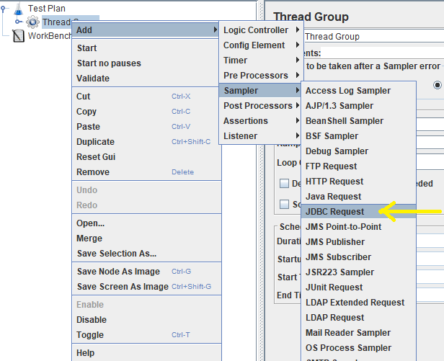

* Enter your variable name which should be the same as the JDBC Connection Configuration.

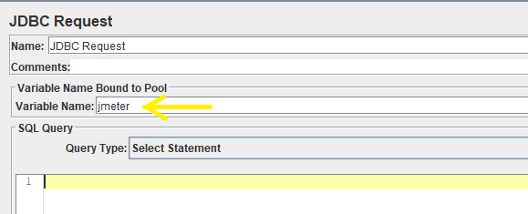

**Step 1.6.5:**  Writing the queries and viewing the result

* Right click on Thread Group.
* Click on Add -> Listener -> View Results Tree.

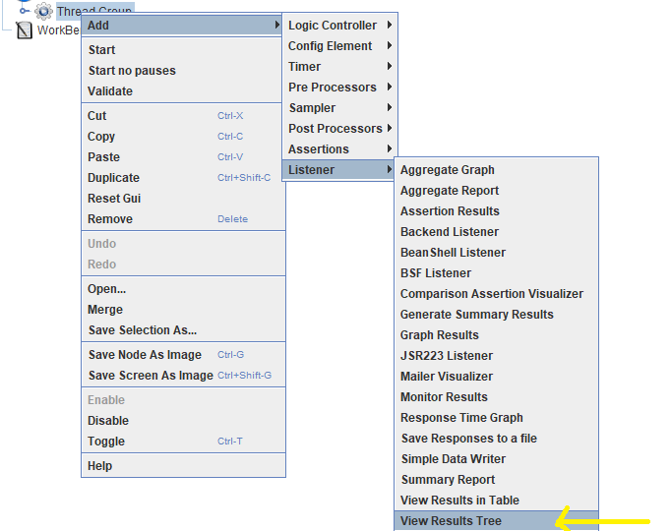

* Write the queries in JDBC Request.

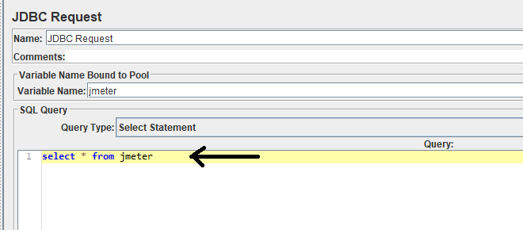

* View the result in **View Results Tree**.
* The sample request result will look like:

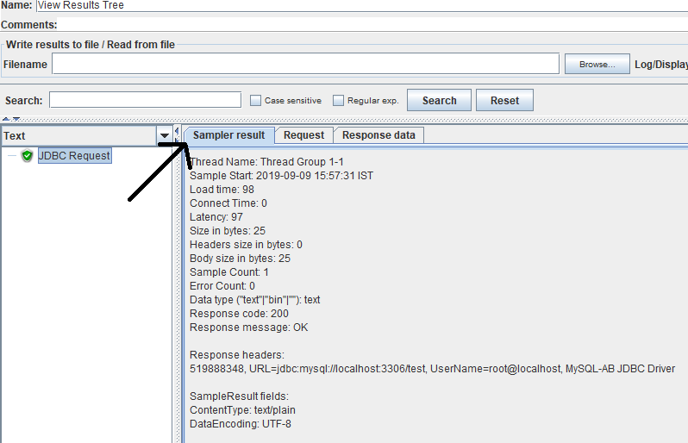

* Click on Request to show queries.

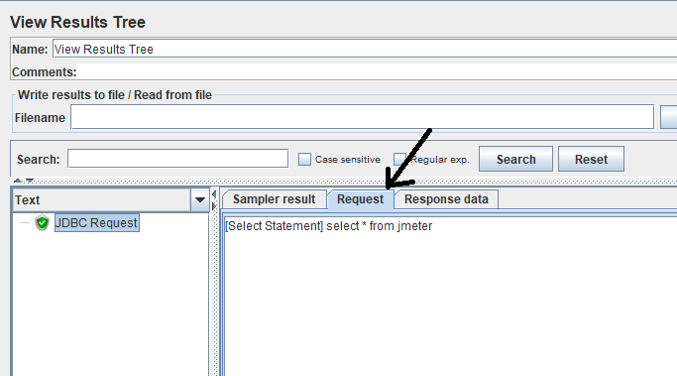

* Click on Response data to show queries output.

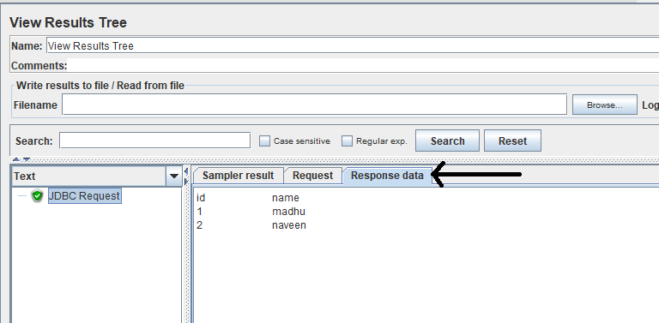

**Step 1.6.6:** Pushing the code to GitHub repositories

Open your command prompt and navigate to the folder where you have created your files.

cd <folder path>

Initialize your repository using the following command:

git init

Add all the files to your git repository using the following command:

git add . 

Commit the changes using the following command:

git commit . -m “Changes have been committed.”

Push the files to the folder you initially created using the following command:

git push -u origin master